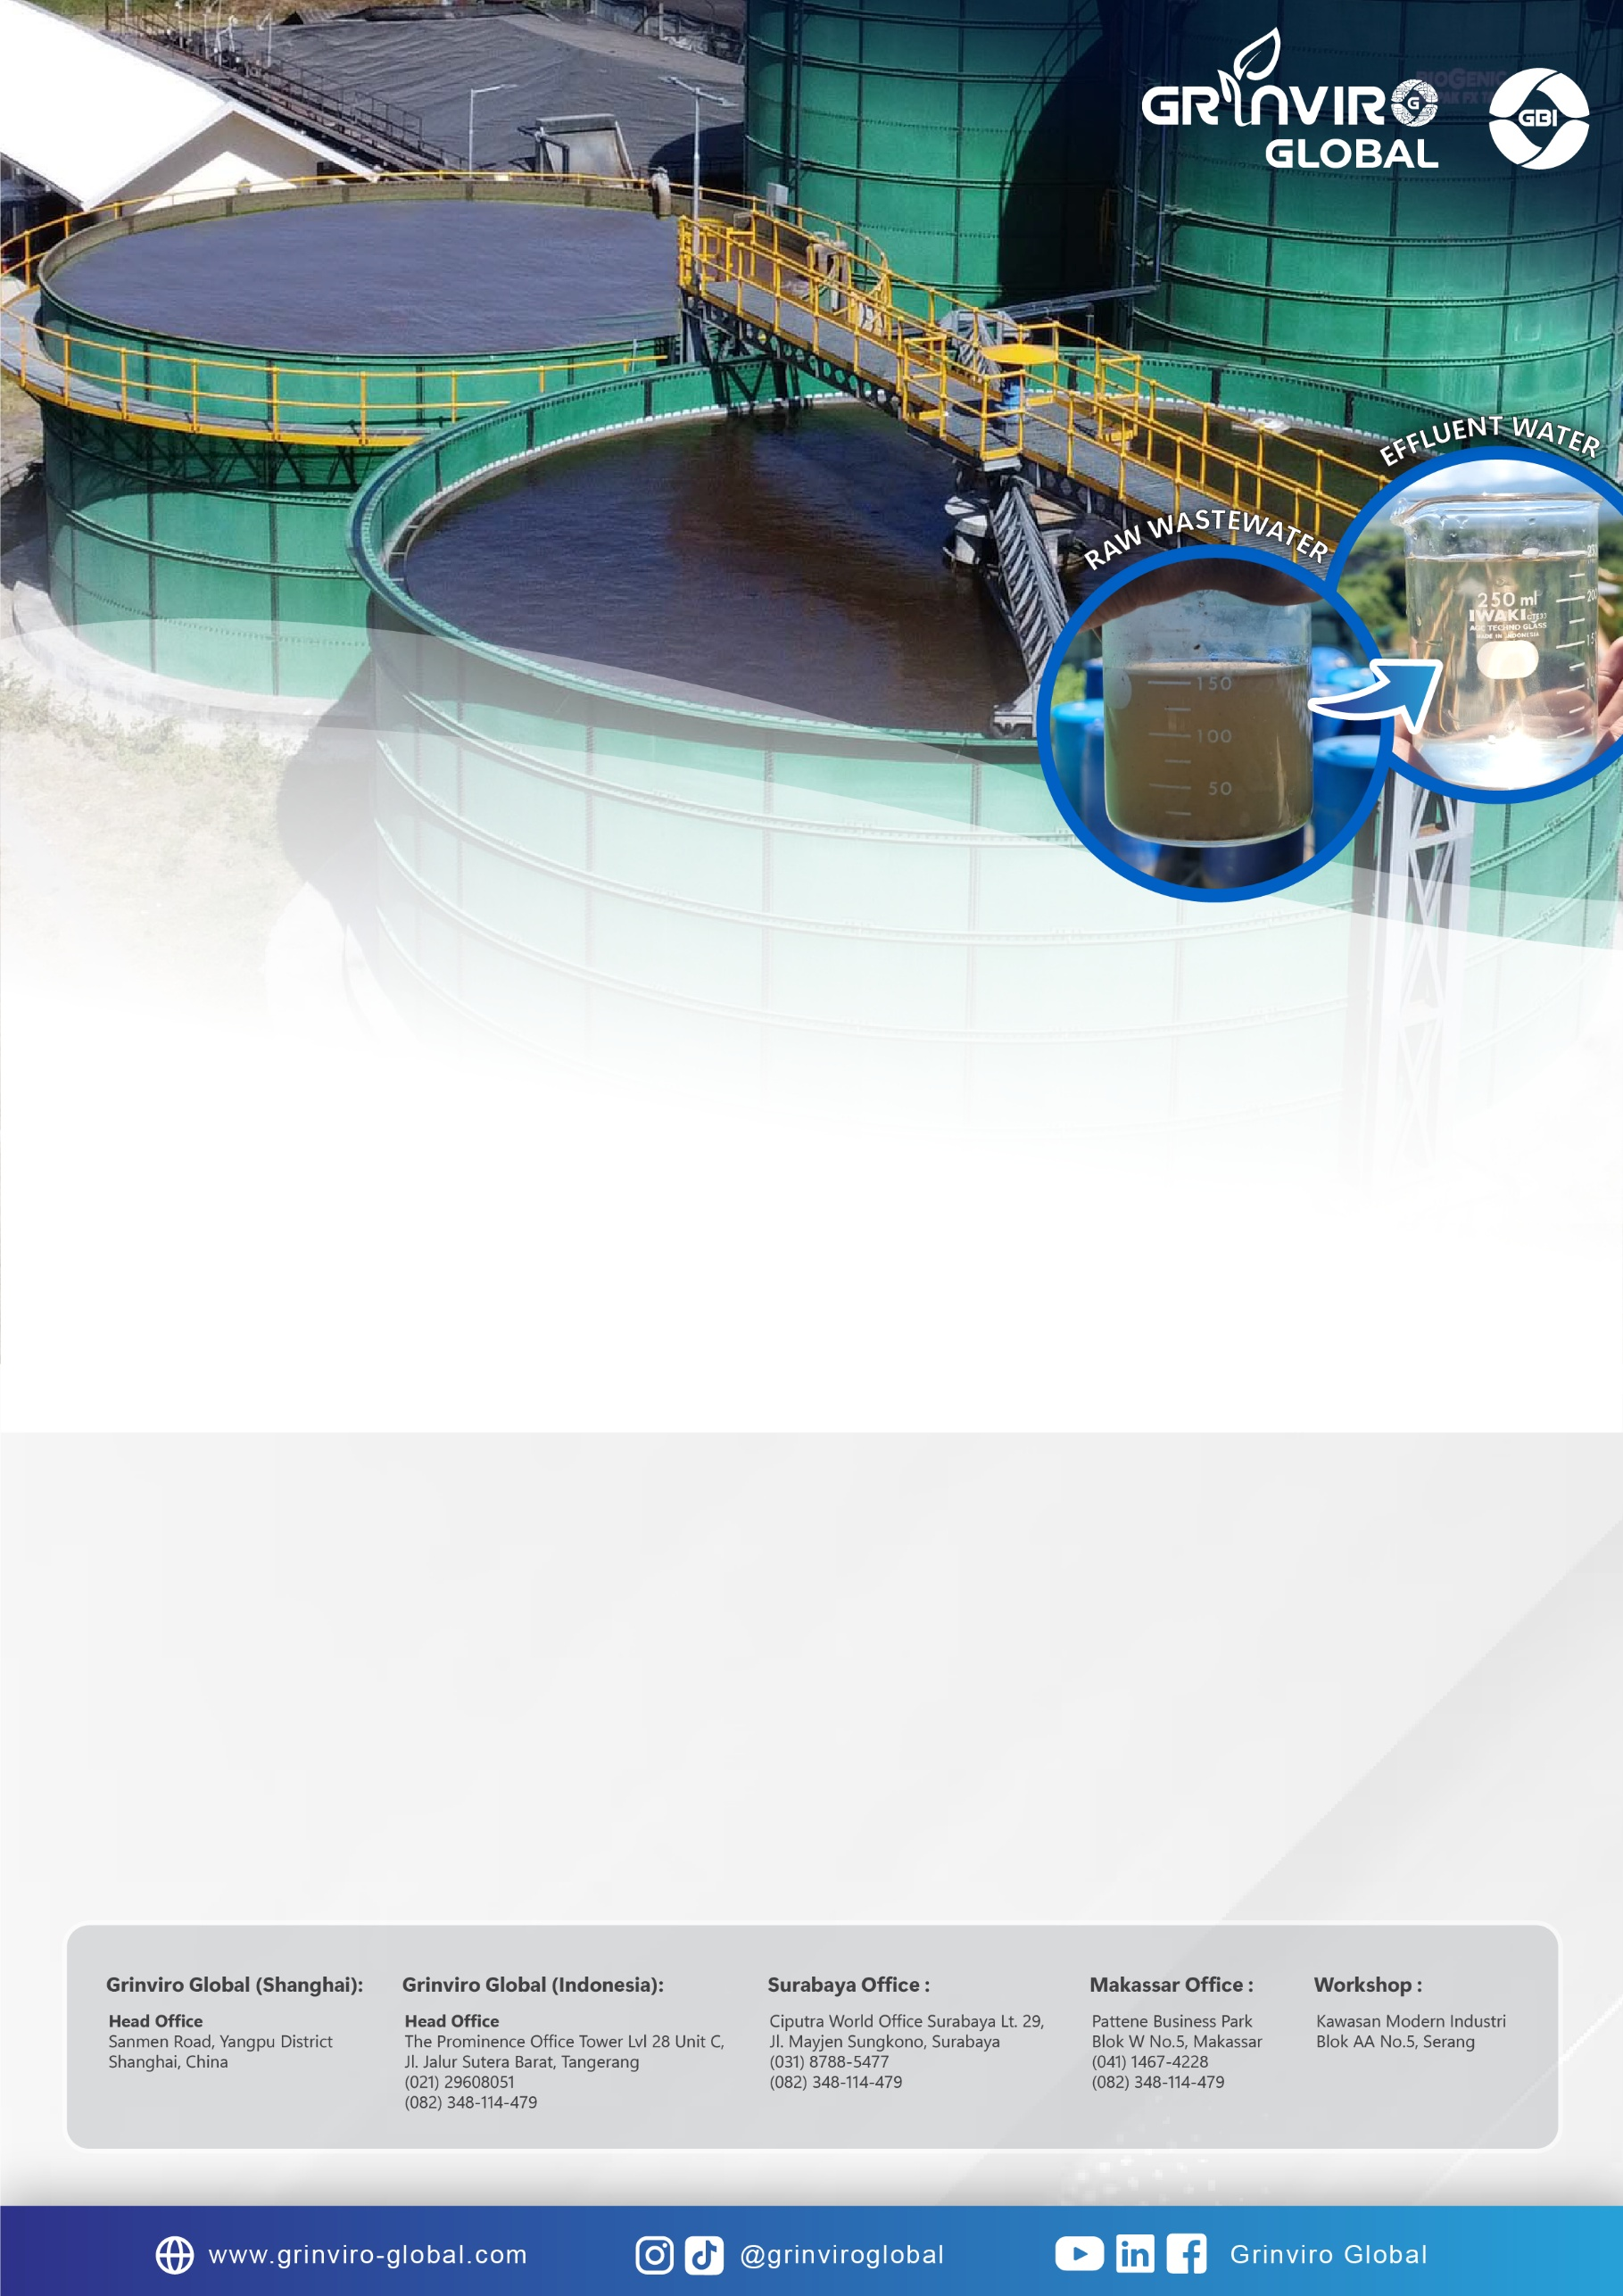sa

**QUOTATION**

**WASTEWATER TREATMENT PLANT -**

**{{DIP_Project Information.B60}} CMD**

**{{DIP_Customer Information.B4}}**



**PT GRINVIRO BIOTEKNO INDONESIA**

Water & Waste Water Treatment System

**Head Office :**

**PT GRINVIRO BIOTEKNO INDONESIA**

**Pergudangan Kosambi 2 Blok A9 No. 11**

**Tangerang – Indonesia**

**Tel : (021) 5437311**

**E-mail :** [sales@grinvirobiotekno.com](mailto:sales@grinvirobiotekno.com)

**Website :** [www.grinvirobiotekno.com](http://www.grinvirobiotekno.com)

**Branch Office :**

**Jakarta – Surabaya – Makassar**

No. : {{QUOTATION_NO.NO}}

Surabaya, {{DATE.NOW}}

**{{DIP_Customer Information.B4}}**

{{DIP_Customer Information.B10}}, {{DIP_Customer Information.B9}} - {{DIP_Customer Information.B8}}

Up : {{DIP_Customer Information.B16}} - {{DIP_Customer Information.B4}}

Perihal : Proposal Sistem {{DIP_Project Information.B3}} – {{DIP_Project Information.B60}} CMD

Mula – mula kami mengucapkan banyak terimakasih telah diberikan kesempatan untuk mengajukan proposal {{DIP_Project Information.B3}} dengan menggunakan teknologi pengolahan secara fisik, kimia, dan biologi. Sistem yang kami ajukan diharapkan mampu mengolah air limbah industri dengan effluent yang sesuai dengan target yang diinginkan. Besar harapan kami teknologi dapat diaplikasikan untuk pengolahan sistem {{DIP_Project Information.B3}} {{DIP_Customer Information.B4}}. Sekali lagi terimakasih atas kesempatan yang telah diberikan kepada kami.

Hormat kami,

{{USER_CODE.NAME}}

{{USER_CODE.POSITION}}

Email: {{USER_CODE.EMAIL}}

Mobile: {{USER_CODE.MOBILE}}

**I. PROCESS DESCRIPTION**

**ANAEROBIC SYSTEM (BIOGENIC WTE)**

**Anaerobic ANAPAK FX – High-Rate Granular Bed Reactor**

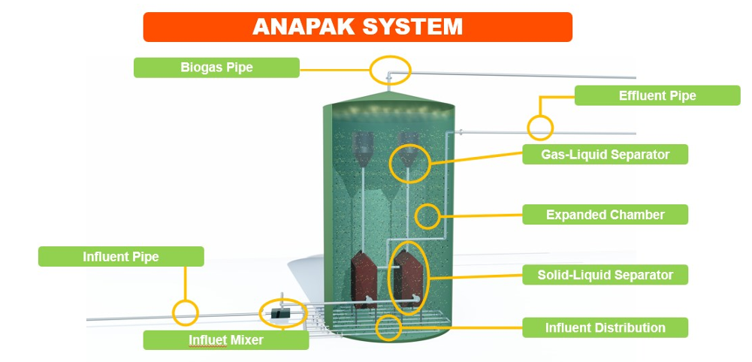

Dalam reaktor ANAPAK-FX koloni bakteri akan membentuk suatu lumpur aktif yang disebut sebagai granulated sludge, dimana sludge yang terbentuk merupakan gabungan jutaan koloni bakter yang berbeda – beda dalam suatu gumpalan yang mirip seperti batu kerikil kecil. Granulated sludge merupakaan keistimewaan dalam proses Anaerobic Granular Bed Reactor (AGBR) dimana sludge yang padat dan berat berbentuk granular cenderung tenggelam kedasar reaktor dan tidak terbuang keluar. Sludge yang pada dan berat akan bekerja optimal dalam menyerap organik secara efisien sehingga menghasilkan kualitas limbah cair olahan dengan COD yang lebih rendah.

Salah satu bagian penting dalam sistem ANAPAK-FX adalah sistem pemisahan biogas, solid dan effluent atau disebut sebagai GLSS (Gas – Liguid – Solid Seperator) atau 3-Phase Separator (3PS). Kegagalan dari sistem 3PS akan menyebabkan sistem ANAPAK tidak bekerja optimal dan menghasilkan effluent dengan kualitas rendah. Sistem GLSS ANAPAK-FX didesain sedemikian rupa menggunakan spesial GLSS sehingga level granular sludge dapat dipertahankan sampai berkisar 70-80% dari volume reaktor. Konsentrasi biomass yang sangat tinggi pada sistem ANAPAK-FX memungkinkan sistem bekerja pada OLR yang sangat tinggi berkisr 20 – 35 Kg.COD/m3. ANAPAK FX-Anaerobic System merupakan pengembangan teknologi dari sistem teknologi WWTP Konvensional. Anapak FX Anaerobic System sangat cocok di aplikasikan pada sistem Waste Water Treatment Plant (WWTP) dengan paremeter COD yang sangat tinggi dengan lahan yang terbatas.

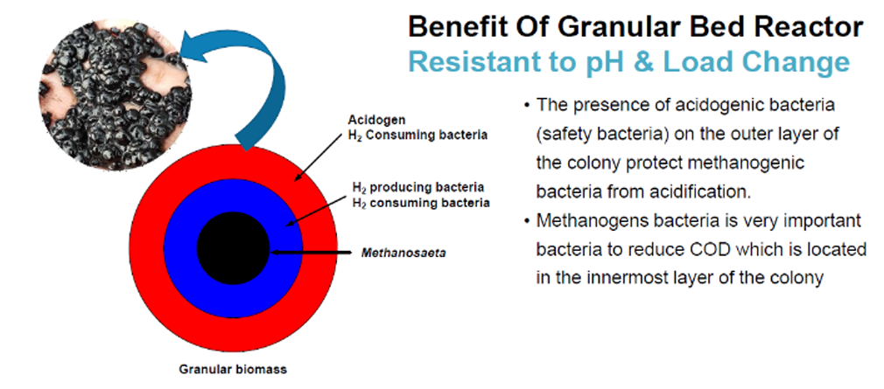

**II. DESIGN BASIS**

**II.1 DESIGN DATA**

|  |  |  |  |  |
| --- | --- | --- | --- | --- |
| **Waste Water Information** | | | | |
| **1.** | **Source** | **Wastewater** | | **Remarks** |
| a. | COD | {{DIP_Project Information.B69}} | mg/liter | Maximum Value |
| b. | BOD | {{DIP_Project Information.B70}} | mg/liter | Maximum Value |
| c. | TSS | {{DIP_Project Information.B71}} | mg/liter | Maximum Value |
| d. | FOG | {{DIP_Project Information.B72}} | mg/liter | Maximum Value |
| e. | pH | {{DIP_Project Information.B68}} | - | Maximum Value |
| f. | Temperature | 33 | Deg C | Maximum Value |
| g. | Flow Rate | {{DIP_Project Information.B80}} | CMD |  |
| **2.** | **WWTP Effluent Warranty** | | | **Remarks** |
| a. | {{EFFLUENT.PARAM_1_NAME}} | {{EFFLUENT.PARAM_1_VALUE}} | {{EFFLUENT.PARAM_1_UNIT}} | {{EFFLUENT.REMARKS}} |
| b. | {{EFFLUENT.PARAM_2_NAME}} | {{EFFLUENT.PARAM_2_VALUE}} | {{EFFLUENT.PARAM_2_UNIT}} |
| c. | {{EFFLUENT.PARAM_3_NAME}} | {{EFFLUENT.PARAM_3_VALUE}} | {{EFFLUENT.PARAM_3_UNIT}} |
| d. | {{EFFLUENT.PARAM_4_NAME}} | {{EFFLUENT.PARAM_4_VALUE}} | {{EFFLUENT.PARAM_4_UNIT}} |
| e. | {{EFFLUENT.PARAM_5_NAME}} | {{EFFLUENT.PARAM_5_VALUE}} | {{EFFLUENT.PARAM_5_UNIT}} |
| f. | {{EFFLUENT.PARAM_6_NAME}} | {{EFFLUENT.PARAM_6_VALUE}} | {{EFFLUENT.PARAM_6_UNIT}} |
| g. | {{EFFLUENT.PARAM_7_NAME}} | {{EFFLUENT.PARAM_7_VALUE}} | {{EFFLUENT.PARAM_7_UNIT}} |
| h. | {{EFFLUENT.PARAM_8_NAME}} | {{EFFLUENT.PARAM_8_VALUE}} | {{EFFLUENT.PARAM_8_UNIT}} |
| i. | {{EFFLUENT.PARAM_9_NAME}} | {{EFFLUENT.PARAM_9_VALUE}} | {{EFFLUENT.PARAM_9_UNIT}} |
| j. | {{EFFLUENT.PARAM_10_NAME}} | {{EFFLUENT.PARAM_10_VALUE}} | {{EFFLUENT.PARAM_10_UNIT}} |
| k. | {{EFFLUENT.PARAM_11_NAME}} | {{EFFLUENT.PARAM_11_VALUE}} | {{EFFLUENT.PARAM_11_UNIT}} |
| l. | {{EFFLUENT.PARAM_12_NAME}} | {{EFFLUENT.PARAM_12_VALUE}} | {{EFFLUENT.PARAM_12_UNIT}} |
| m. | {{EFFLUENT.PARAM_13_NAME}} | {{EFFLUENT.PARAM_13_VALUE}} | {{EFFLUENT.PARAM_13_UNIT}} |
| n. | {{EFFLUENT.PARAM_14_NAME}} | {{EFFLUENT.PARAM_14_VALUE}} | {{EFFLUENT.PARAM_14_UNIT}} |
| o. | {{EFFLUENT.PARAM_15_NAME}} | {{EFFLUENT.PARAM_15_VALUE}} | {{EFFLUENT.PARAM_15_UNIT}} |
| p. | {{EFFLUENT.PARAM_16_NAME}} | {{EFFLUENT.PARAM_16_VALUE}} | {{EFFLUENT.PARAM_16_UNIT}} |
| q. | {{EFFLUENT.PARAM_17_NAME}} | {{EFFLUENT.PARAM_17_VALUE}} | {{EFFLUENT.PARAM_17_UNIT}} |
| r. | {{EFFLUENT.PARAM_18_NAME}} | {{EFFLUENT.PARAM_18_VALUE}} | {{EFFLUENT.PARAM_18_UNIT}} |
| s. | {{EFFLUENT.PARAM_19_NAME}} | {{EFFLUENT.PARAM_19_VALUE}} | {{EFFLUENT.PARAM_19_UNIT}} |
| t. | {{EFFLUENT.PARAM_20_NAME}} | {{EFFLUENT.PARAM_20_VALUE}} | {{EFFLUENT.PARAM_20_UNIT}} |
| u. | {{EFFLUENT.PARAM_21_NAME}} | {{EFFLUENT.PARAM_21_VALUE}} | {{EFFLUENT.PARAM_21_UNIT}} |
| v. | {{EFFLUENT.PARAM_22_NAME}} | {{EFFLUENT.PARAM_22_VALUE}} | {{EFFLUENT.PARAM_22_UNIT}} |

**II.2 .MAIN SYSTEM DESIGN**

|  |  |  |  |
| --- | --- | --- | --- |
| **No** | **Design System** | | |
| **1.** | **Biological System – Anaerobic System** | | **Remarks** |
|  | Organic Removal System | Anaerobic System |  |
|  | Anaerobic Type | ANAPAK FX |  |
|  | Operation Profile | Automatic system:   * Automatic pH Controller System * Automatic influent Flow control system |  |
|  | Biomass Type | Granular biomass |  |
|  | Mixing System | ANAPAK FX System |  |
|  | GLS Separator System | Modular 3 Phase Separator |  |
|  | Reactor Type | Bolted Panel Tank |  |
|  | Max. Feed Flowrate | {{DATA_TEMP.B4}} CMD |  |
|  | Max. Organic Load Design | {{DATA_TEMP.B5}} Kg.COD/day |  |
|  | Feed COD | {{DATA_TEMP.B6}} mg/L |  |
|  | COD removal | 70% - 80% | *Estimated |
|  | pH Adjustment | Automatic pH Adjustment |  |
|  | Biogas Flare System | Open Flare System |  |
|  | Surplus Sludge Per Day | {{DATA_TEMP.B7}} Kg.DS/day |  |
|  | Biogas Production | {{DATA_TEMP.B8}} NCBM/day | *Estimated |
|  | Methane Production | {{DATA_TEMP.B9}} NCBM/day | *Estimated |
|  | H2S Content (biogas) | < 0,8% | *Estimated |

**IV. BILL OF MATERIAL**

**IV.1 MECHANICAL AND ELECTRICAL WORK FOR PHASE 1**

|  |  |  |  |  |
| --- | --- | --- | --- | --- |
| **No** | **Specifications** | | | |
| **1** | **All Transfer Pump** | | | |
|  | **ANAPAK-FX 1 Feed Pump (TP-04)**  Pump Type  Material   * Pump Body * Impeller * Shaft   Flowrate  Total Head  Power | End Suction Pump  SS304  SS304  SS304  {{DATA_TEMP.B14}} CMh  {{DATA_TEMP.B15}} meter  {{DATA_TEMP.B16}} kW /3 phase/ 380V | 2 unit  (1W+1S) | CNP/LEO/  LEP/EQUAL |
| **2** | **Anaerobic System** | | | |
|  | **BIOGENIC Anaerobic Reactor**  Tank Type  Dimension  Complete With | Bolted Tank with Epoxy Lining  D: {{DATA_TEMP.B11}} m, H: {{DATA_TEMP.B12}} m  Tank Cover / Ladder / Walk Way platform/ Manhole/Feed & Outlet Nozzle/Drain Nozzle | 2 set | BIOGENIC – Grinviro |
|  | **Feed Distribution**  Type  Material   * Feed lateral * Feed Nozzle * Inner lateral feed | Bottom Feed Lateral Distribution  SUS304  SUS304  SUS304 | 1 lot | BIOGENIC – Grinviro |
|  | **Sludge Sampling Profile**  Type  Pipe material  Sludge Sampling  Sampling Port Material | Gravity Sampling Profile  SS304  Along Tank Height  SS304 | 1 lot | BIOGENIC – Grinviro |
|  | **Three Phase Separator**  GLSS System  Settler Type Material  Complete with | ANAPAK FX Double Stage Settler  Carbon steel with Epoxy lining  Granular Biomass Venturi Mixer | 1 lot | BIOGENIC – Grinviro |
| **3** | **Biogas Flare System** | | | |
|  | **Biogas Flare system**  Flaring System  Ignition Equipment  Biogas Housing Chamber  Gas Sealer | Open Flare System  High Voltage Spark Transformer  SS304  Non-Return Water Sealer with SS304 Housing | 1 set | FLOWREX |
| **4** | **Chemical Dosing System** | | | |
|  | **Dosing Pump**  Capacity  Power  Application | 5.5 - 60 LPH  0.09 – 0.37 kW/3 phase/380 V  For : Caustic/Nutrient | 1 lot | NEWDOSE/SEKO/  EQUAL |
|  | **Agitator**  Power | 0.55 kW/3 phase/380 V | 1 lot | FLOWREX |
|  | **Chemical Tank**  Capacity  Application  Material | 100 – 1000 L  For : Caustic/Nutrient  PE | 1 lot | CANATURE |
| **5** | **Instrument** | | | |
|  | **Digital Flowmeter**  Flowmeter Type  Position  Transmitter Type  Display  Material  Output Signal | Electromagnetic Flowmeter  Inlet dan outlet WWTP, ANAPAK system (Inlet dan recycle line)  Compact Type  LCD Display  Body Casing: ABS  Electrode: SS316L  4 – 20 mA | 1 lot | FLOWREX |
|  | **Pressure Transmitter**  Type  Sensor  Pressure Range | Digital Pressure Transmitter  Piezo electric  0.00 – 20 bar | 1 lot | FLOWREX |
|  | **pH Sensor**  Type  Location  Temperature  Measurement Range  Analog Output | pH Sensor with Temperature Compensation  ANAPAK system (Inlet dan output line)  Auto recognition with NTC10K  0.00 – 14.00  4 – 20 mA | 1 lot | FLOWREX |
|  | **Pressure Gauge**  Type  Location  Model | Bourdon tube  (See PID)  232,5 – dia 65 mm | 1 lot | FLOWREX |
|  | **Level Control**  Type  Location | Level switch indicator controller  SEE PID | 1 lot | FLOWREX |
| **6** | **System Pipe Connection** | | | |
|  | **Pipe**  All water transfer  Header ANAPAK  Lateral Inner ANAPAK | HDPE  SS  HDPE | 1 lot | LOCAL/  EQUAL |
|  | Manual Valve  All pipe isolation valves | Lever handle Butterfly Valve  (Aluminum Body/SS304 Disc/EPDM seat)  3pc Ball Valve | 1 lot | 1. COVNA/ EQUAL |
|  | Automatic Valve  Automatic Valve Drive  Valve Type | Motorized Actuator  Butterfly Valve System | 1. 1 lot   1 lot | COVNA/ EQUAL |
| **7** | **Electrical System** | | | |
|  | Panel Type  Control System  Pump/Dosing control  Cable Tray  Cable  PC SCADA | Standing Panel Indoor Application  Double Exhaust Fan System  Material : Carbon Steel With Corrotion Prevention  PLC System with HMI  Component MCC  Variable Speed Drive  Galvanized Metal Tray  Power Cable & Signal Cable  SIMATIC WINCC v7.5 sp2 | 1 lot  1 lot  1 lot  1 lot  1 lot  1 lot  1 lot | Grinviro  SIEMENS/  EQUAL  Schneider  SAJ  Local  ETERNA/  EQUAL  LOCAL |
| **8** | **Design / Installation / Commissioning** | | | |
|  | * + - Material Shipping     - Biomass Seeding     - Installation     - Operator Training & Transfer Knowledge | To {{DIP_Customer Information.B10}}  All Anaerobic and Aerobic Reactor  All Mechanical & Electrical  During Commissioning time | 1 lot | By Grinviro |

# **V. SPLIT OF RESPONSIBILITY**

|  |  |  |  |  |
| --- | --- | --- | --- | --- |
| **No.** | **Work scope** | **Client** | **Contractor** | **Remarks** |
|  | **Authority Submission** | | | |
|  | Permits - Persetujuan Teknis (PERTEK) | {{DIP_Data Input.B5}} | {{DIP_Data Input.C5}} | {{DIP_Data Input.D5}} |
|  | Expenses associated with the land acquisition (such as “Izin Pembebasan Lahan”) | {{DIP_Data Input.B6}} | {{DIP_Data Input.C6}} | {{DIP_Data Input.D6}} |
|  |
|  | To obtain license to operate {{DIP_Project Information.B3}} such as SLF (Sertifikat Laik Fungsi) | {{DIP_Data Input.B7}} | {{DIP_Data Input.C7}} | {{DIP_Data Input.D7}} |  |
|  |
|  | License for secondary waste, where needed (such as “Upaya Pengelolaan Lingkungan Hidup (UKL) - Upaya Pemantauan Lingkungan Hidup (UPL)”) | {{DIP_Data Input.B8}} | {{DIP_Data Input.C8}} | {{DIP_Data Input.D8}} |  |
|  |
|  |
|  |
|  |
|  | Others local Authority, where needed (such as “Izin Mendirikan Bangunan (IMB)) | {{DIP_Data Input.B9}} | {{DIP_Data Input.C9}} | {{DIP_Data Input.D9}} |  |
|  |
|  | **Civil and Structural Works – {{DIP_Project Information.B3}} System** |  |  |  |  |
|  |
|  | Land and ground clearance, compaction, and development works | {{DIP_Data Input.B11}} | {{DIP_Data Input.C11}} | {{DIP_Data Input.D11}} |  |
|  |
|  | Warehouse / Workshop, Site Office, Construction Power Supply, Project Site Location Security | {{DIP_Data Input.B12}} | {{DIP_Data Input.C12}} | {{DIP_Data Input.D12}} |  |
|  |
|  |
|  | Water and electrical during the construction | {{DIP_Data Input.B13}} | {{DIP_Data Input.C13}} | {{DIP_Data Input.D13}} |  |
|  | Piling work and RC foundation | {{DIP_Data Input.B14}} | {{DIP_Data Input.C14}} | {{DIP_Data Input.D14}} |  |
|  | Loading and unloading all material to laydown area | {{DIP_Data Input.B15}} | {{DIP_Data Input.C15}} | {{DIP_Data Input.D15}} |  |
|  |
|  | GA drawing, loading information, and installation requirement | {{DIP_Data Input.B16}} | {{DIP_Data Input.C16}} | {{DIP_Data Input.D16}} |  |
|  |
|  | Design and drawing for {{DIP_Project Information.B3}} concrete tank, pump/blower room, control room, chemical room | {{DIP_Data Input.B17}} | {{DIP_Data Input.C17}} | {{DIP_Data Input.D17}} |  |
|  |
|  |
|  | Foundation for {{DIP_Project Information.B3}} containerized tank, pump/blower room, control room, chemical room | {{DIP_Data Input.B18}} | {{DIP_Data Input.C18}} | {{DIP_Data Input.D18}} |  |
|  |
|  |
|  | Maintenance platform and safety handrails for non-RC items | {{DIP_Data Input.B19}} | {{DIP_Data Input.C19}} | {{DIP_Data Input.D19}} |  |
|  |
|  | *Note: RC – reinforced concrete* |  |  |  |  |
|  | **Mechanical and Piping – {{DIP_Project Information.B3}} System** |  |  |  |  |
|  | Supply and installation of all mechanical material for {{DIP_Project Information.B3}} system | {{DIP_Data Input.B22}} | {{DIP_Data Input.C22}} | {{DIP_Data Input.D22}} |  |
|  |
|  | Design, testing and commissioning of {{DIP_Project Information.B3}} system | {{DIP_Data Input.B23}} | {{DIP_Data Input.C23}} | {{DIP_Data Input.D23}} |  |
|  |
|  | Piping and Pipe rack outside battery limit (OSBL) | {{DIP_Data Input.B24}} | {{DIP_Data Input.C24}} | {{DIP_Data Input.D24}} |  |
|  |
|  | Inlet wastewater transfer piping to WWTP System | {{DIP_Data Input.B25}} | {{DIP_Data Input.C25}} | {{DIP_Data Input.D25}} |  |
|  |
|  | Piping & final system for effluent {{DIP_Project Information.B3}} to discharge | {{DIP_Data Input.B26}} | {{DIP_Data Input.C26}} | {{DIP_Data Input.D26}} |  |
|  |
|  | Piping and Pipe rack inside battery limit (ISBL) | {{DIP_Data Input.B27}} | {{DIP_Data Input.C27}} | {{DIP_Data Input.D27}} |  |
|  | Mechanical Installation & Erection Manpower & Labor | {{DIP_Data Input.B28}} | {{DIP_Data Input.C28}} | {{DIP_Data Input.D28}} |  |
|  |
|  | All General Access (Roads, Sidewalks, Pathways & Entrances) | {{DIP_Data Input.B29}} | {{DIP_Data Input.C29}} | {{DIP_Data Input.D29}} |  |
|  |
|  | Loading and unloading all material to laydown area | {{DIP_Data Input.B30}} | {{DIP_Data Input.C30}} | {{DIP_Data Input.D30}} |  |
|  |
|  | **Electrical and Instrumentation** |  |  |  |  |
|  | Electrical feeder to main power control panel (MCC) | {{DIP_Data Input.B32}} | {{DIP_Data Input.C32}} | {{DIP_Data Input.D31}} |  |
|  |
|  | Electricity during the installation and commissioning of the system | {{DIP_Data Input.B33}} | {{DIP_Data Input.C33}} | {{DIP_Data Input.D32}} |  |
|  |
|  | Purchase, installation, cable laying, testing | {{DIP_Data Input.B34}} | {{DIP_Data Input.C34}} | {{DIP_Data Input.D33}} |  |
|  | Lightening protector | {{DIP_Data Input.B35}} | {{DIP_Data Input.C35}} | {{DIP_Data Input.D34}} |  |
|  | Lighting on {{DIP_Project Information.B3}} system | {{DIP_Data Input.B36}} | {{DIP_Data Input.C36}} | {{DIP_Data Input.D35}} |  |
|  | Panel control including their outgoing cables, termination, complete installation, testing & commissioning | {{DIP_Data Input.B37}} | {{DIP_Data Input.C37}} | {{DIP_Data Input.D36}} |  |
|  |
|  |
|  | Instrument supply, installation, calibration, loop check and commissioning | {{DIP_Data Input.B38}} | {{DIP_Data Input.C38}} | {{DIP_Data Input.D37}} |  |
|  |
|  | **Monitoring and Control System** |  |  |  |  |
|  | Local panel control system | {{DIP_Data Input.B40}} | {{DIP_Data Input.C40}} | {{DIP_Data Input.D40}} |  |
|  | **Testing and Commissioning** |  |  |  |  |
|  | Continuous 24-hours performance test of the wastewater treatment system AT DESIGN CAPACITY with design influent quality and effluent discharged comply to contract | {{DIP_Data Input.B42}} | {{DIP_Data Input.C42}} | {{DIP_Data Input.D42}} |  |
|  |
|  |
|  |
|  | Chemical during commissioning | {{DIP_Data Input.B43}} | {{DIP_Data Input.C43}} | {{DIP_Data Input.D43}} |  |
|  | Commissioning spare parts | {{DIP_Data Input.B44}} | {{DIP_Data Input.C44}} | {{DIP_Data Input.D44}} |  |
|  | Sufficient water and electricity during the commissioning | {{DIP_Data Input.B45}} | {{DIP_Data Input.C45}} | {{DIP_Data Input.D45}} |  |
|  |
|  | Analyse the parameters (for {{DIP_Project Information.B3}} system) as per regulation during the commissioning by the internal laboratory (the contractor) | {{DIP_Data Input.B46}} | {{DIP_Data Input.C46}} | {{DIP_Data Input.D46}} |  |
|  |
|  |
|  | Analyse the parameters (for {{DIP_Project Information.B3}} system) as per regulation at the end of the commissioning by the external laboratory | {{DIP_Data Input.B47}} | {{DIP_Data Input.C47}} | {{DIP_Data Input.D47}} |  |
|  |
|  |
|  | **Others** |  |  |  |  |
|  | HIRAC for the site installation works | {{DIP_Data Input.B49}} | {{DIP_Data Input.C49}} | {{DIP_Data Input.D49}} |  |
|  | Classroom/ Virtual training for {{DIP_Project Information.B3}} operation | {{DIP_Data Input.B50}} | {{DIP_Data Input.C50}} | {{DIP_Data Input.D50}} |  |
|  |
|  | Operation manuals and as-built drawings | {{DIP_Data Input.B51}} | {{DIP_Data Input.C51}} | {{DIP_Data Input.D51}} |  |
|  | Workmen Compensation | {{DIP_Data Input.B52}} | {{DIP_Data Input.C52}} | {{DIP_Data Input.D52}} |  |
|  | **Documentation** |  |  |  |  |
|  | Project schedule | {{DIP_Data Input.B54}} | {{DIP_Data Input.C54}} | {{DIP_Data Input.D54}} |  |
|  | Piping & instruments diagram | {{DIP_Data Input.B55}} | {{DIP_Data Input.C55}} | {{DIP_Data Input.D55}} |  |
|  | Single-line diagram | {{DIP_Data Input.B56}} | {{DIP_Data Input.C56}} | {{DIP_Data Input.D56}} |  |
|  | Major equipment list | {{DIP_Data Input.B57}} | {{DIP_Data Input.C57}} | {{DIP_Data Input.D57}} |  |
|  | All equipment list (tagged items) | {{DIP_Data Input.B58}} | {{DIP_Data Input.C58}} | {{DIP_Data Input.D58}} |  |
|  | Detail engineering design drawing | {{DIP_Data Input.B59}} | {{DIP_Data Input.C59}} | {{DIP_Data Input.D59}} |  |
|  | Material approval document | {{DIP_Data Input.B60}} | {{DIP_Data Input.C60}} | {{DIP_Data Input.D60}} |  |
|  | Operations and maintenance manual (O&M) | {{DIP_Data Input.B61}} | {{DIP_Data Input.C61}} | {{DIP_Data Input.D61}} |  |

**VI. TERMS AND CONDITIONS**

|  |  |
| --- | --- |
| Terms | Cost And Freight (CFR) {{DIP_Customer Information.B10}}, {{DIP_Customer Information.B9}}, {{DIP_Customer Information.B8}} |
| Payments | * {{DIP_Data Input.B69}} * {{DIP_Data Input.B70}} * {{DIP_Data Input.B71}} * {{DIP_Data Input.B72}} |
| Due Dates | All invoices are due and payable at the specified payment date or {{DIP_Project Information.D23}} after invoice date if no payment schedule has been specified in the Sales Oder Contract or in Seller's confirmation of order. In case Buyer defaults in payment, Buyer shall be subject to a default late payment penalty of 1.0% of the outstanding amounts due to Seller for every calendar week or part thereof. |
| Packing | All items suitably packed for overland transport by trucking |
| Delivery | To be determined after confirmation by PO/SPK and down payment |
| System Warranty | 1. The system will produce the effluent as refers to the Government’s permit, but the warranty has been given with conditions below:  * The system operated as the basic design and follows the limit of the inlet flow * The system operated as its SOP * The raw water temperature is within the operational value of the basic design * All equipment/system equipment works properly and is operated properly  1. The warranty is valid if all the systems are installed by GRINVIRO. 2. The default warranty is valid for 365 calendar days since the system has been commissioned or after the system has reached the parameters quality as standard parameters. If the installed product/equipment/material is defective during fabrication (manufacturing defect)/delivery/installation or during commissioning, GRINVIRO will immediately repair or replace the product/equipment/material. 3. If there is damage to the system, which is operational negligence during the warranty period:  * GRINVIRO will provide support in the form of free repair services * If there is a replacement of material/equipment parts, it will be entirely the burden of the buyer * In this case, all accommodation costs (transportation, food and housing costs) are borne by the buyer * When the warranty period is over, the buyer will be charged for repairs and or replacement costs for equipment parts/materials (if any)  1. In this case, the buyer is fully aware of the responsibility for the correct operation and according to the SOP and master’s the basics of Wastewater Treatment system science for good system operation and maintenance 2. GRINVIRO will provide the certificate of warranty |
| Equipment Warranty | 1. Equipment outside the manufacture of GRINVIRO will be given a warranty following a supplier warranty. 2. GRINVIRO will provide the certificate of warranty for equipment by principle. |
| Termination for Convenience | In case the Buyer seeks Termination for convenience of this Contract, such termination shall be effective upon Seller’s receipt of Buyer’s written notice of termination and payment of termination charges in accordance with the Termination Schedule. If Buyer terminates this Contract for convenience, title to the Equipment shall remain with the Seller. Seller may suspend performance upon receipt of Buyer’s termination notice, without incurring any liability to   |  |  | | --- | --- | | Receipt of Termination Notice by Seller | Total Termination Charges, Percent of Total Contract Price | | 1 – 30 days (after DP received) | 20% | | 31 – 60 days | 40% | | 61 – 90 days | 60% | | 91 days – Date of RTS | 80% | | After Date of RTS | 100% | |
| Remarks | The technical specifications may vary between equivalent suppliers and/ or technical details |
| Exchange Rate | This proposal is based on an exchange rate of IDR 16,500 to USD. If the rate exceeds this value, it will impact the project/equipment cost |
| Validity | 1 month from date of quotation issuance |
| Taxes | Exclude PPN 11 % and other taxes |

